***Impact of Gun-Laws in America***

Table of Contents

Introduction 3

Exploratory Data Analysis 5

Comparing different Types of models 8

Pooled OLS 9

Entity Fixed Effects Model 10

Time Fixed Effect Model 11

Two way Fixed Effects Models 12

Hypothesis Testing 13

Conclusions 18

# 

# Introduction

The impact of guns on crime in America has triggered a lot of public debate.

Many strongly believe that state laws enabling citizens to carry concealed handguns had reduced crime. According to this view, gun control laws take away guns from law-abiding citizens, while would-be criminals ignore those leaving potential victims defenseless.

Following this view, The National Rifle Association (NRA) and many politicians across the country advance the cause of greater freedom to carry guns.

As a result, many states in the United States have passed right-to-carry laws (also known as a shall-issue laws). A Shall-issue law is one that requires that governments issue concealed carry handgun permits to any applicant who meets the necessary criteria. These criteria are: the applicant must be an adult, have no significant criminal record, and no history of mental illness and successfully complete a course in firearms safety training (if required by law). If these criteria are met, the granting authority has no discretion in the awarding of the licenses, and there is no requirement of the applicant to demonstrate "good cause".

***“Do shall-issues law reduce crime-or not?”***

**Documentation for Guns Data:**

Guns is a balanced panel of data on 50 US states, plus the District of Columbia (for a

total of 51 “states”), by year for 1977 – 1999. Each observation is a given state in a given year. There are a total of 51 states × 23 years = 1173 observations

***Variable Definitions-***

|  |  |
| --- | --- |
| Variable | Definition |
| vio | violent crime rate (incidents per 100,000 members of the population) |
| rob | robbery rate (incidents per 100,000) |
| mur | murder rate (incidents per 100,000) |
| shall | = 1 if the state has a shall-carry law in effect in that year  = 0 otherwise |
| incarc_rate | incarceration rate in the state in the previous year (sentenced  prisoners per 100,000 residents; value for the previous year) |
| density | population per square mile of land area, divided by 1000 |
| avginc | real per capita personal income in the state, in thousands of dollars |
| pop | state population, in millions of people |
| pm1029 | percent of state population that is male, ages 10 to 29 |
| pw1064 | percent of state population that is white, ages 10 to 64 |
| pb1064 | percent of state population that is black, ages 10 to 64 |
| stateid | ID number of states (Alabama = 1, Alaska = 2, etc.) |
| year | Year (1977-1999) |

In this project, we aim to determine the causal effect of gun control laws on crimes. There are three dependent variables we will consider when it comes to gun control laws:

* vio – Violent Crime Rate per 100,000 people
* mur – Murder Crime Rate per 100,000 people
* rob – Robbery Crime Rate per 100,000 people

Our explanatory variables are:

* Shall - 1 if the state has a shall-carry law in effect in that year, 0 otherwise
* Incarc_rate - incarceration rate in the state in the previous year (sentenced prisoners per 100,000 residents; value for the previous year)
* Density - population per square mile of land area, divided by 1000
* Avginc - real per capita personal income in the state, in thousands of dollars
* Pop - state population, in millions of people
* Pm1029 - percent of state population that is male, ages 10 to 29
* Pw1064 - percent of state population that is white, ages 10 to 64
* Pb1064 - percent of state population that is black, ages 10 to 64
* Stateid - ID number of states (Alabama = 1, Alaska = 2, etc.)
* Year - Year from 1977-1999

According to economic theory, we believe that states with shall-issue laws have a lower crime rate. Since more people are allowed to carry guns, criminals are likely to be more careful.

Generally, criminals lurk in areas where there is lower police presence; however, with this law in place, there is a higher probability of armed civilians acting against crime in the name of self-defence. Additionally, vigilantism is also likely to play a role to reduce crimes — if someone is getting robbed, a bystander is more likely to get involved in the situation if they are armed. The criteria to conceal carry under this law are:

* Applicants must be adults
* Significant crime records make a person ineligible to carry a gun
* There should be no history of mental health disorders for applicants
* A firearms safety course must be completed

We will also try to see how other variables affect crime rates.

# Exploratory Data Analysis

For this analysis, there are a few key variables that are likely to impact crime, apart from gun control laws. If we leave these variables out, the model is likely to suffer from an omitted variable bias, leading to imprecise coefficients.

First, we will do some summary statistics to better understand the data.

**Summary Statistics:**

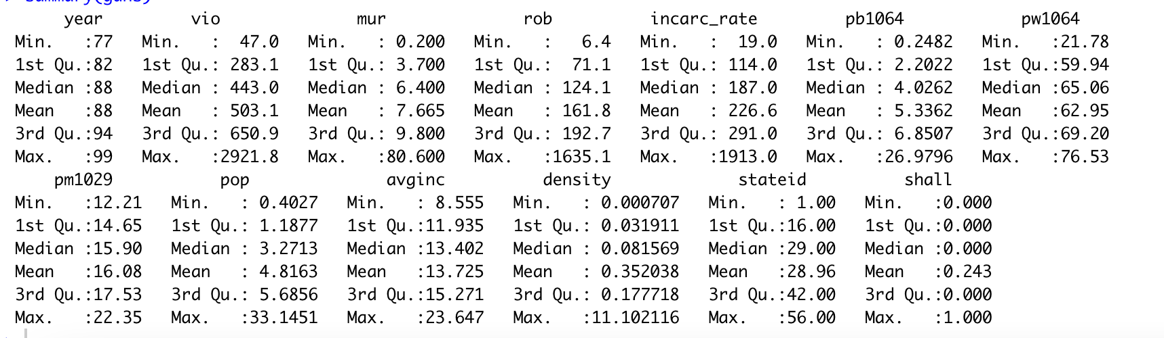

**Corrplot:**

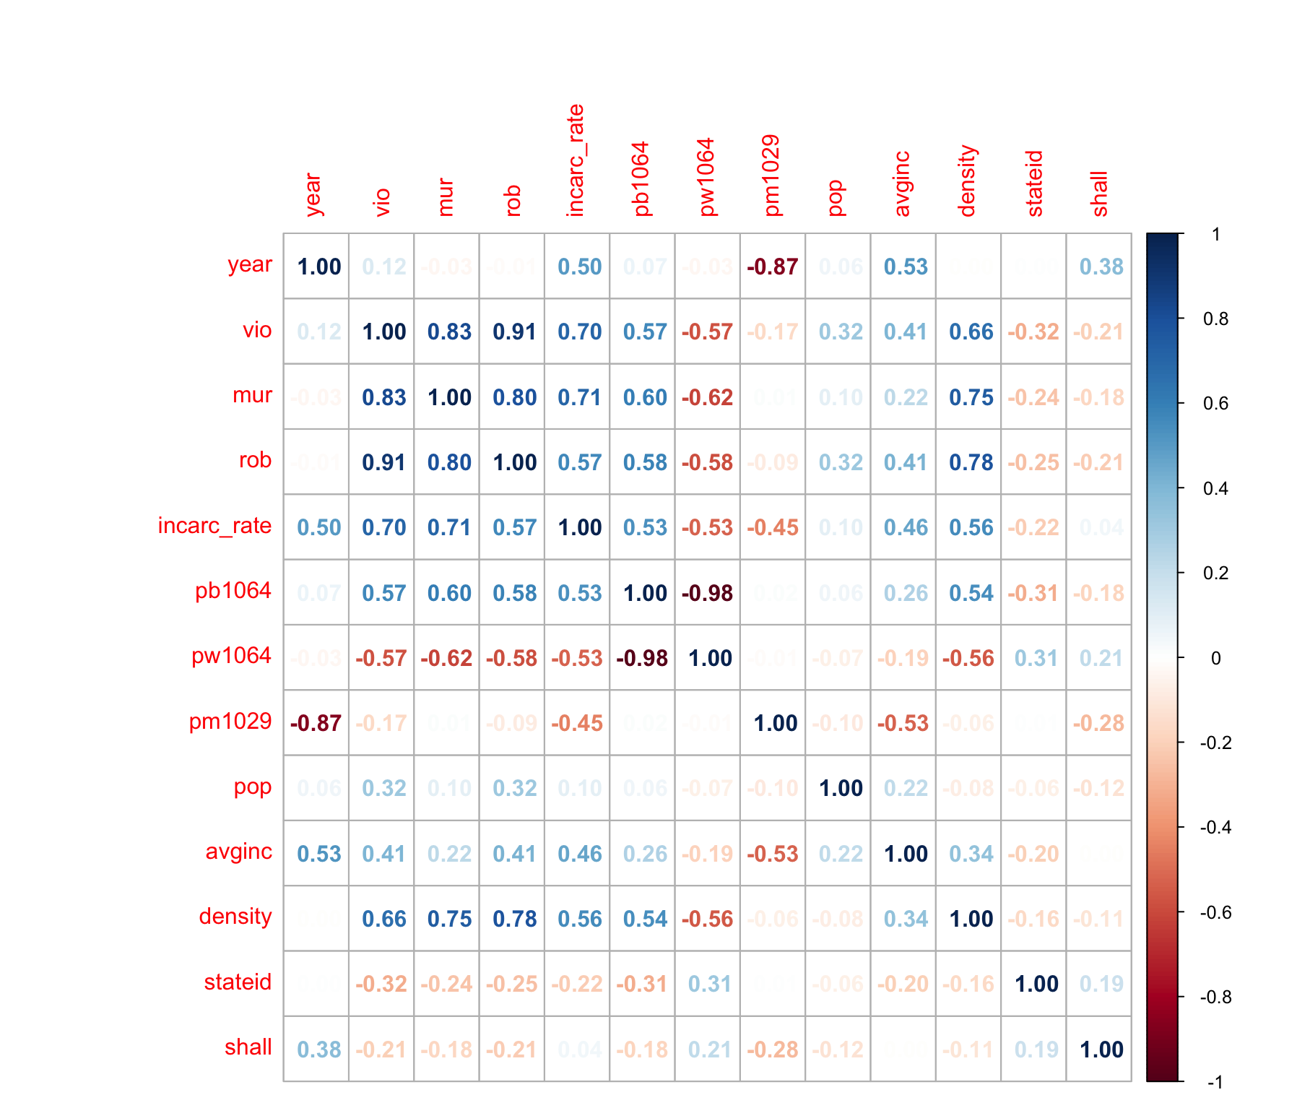

A few observations:

* The three response variables *vio,mur* and *rob* are highly correlated which makes sense as its understandable a place with higher crime will have higher violence and robberies too
* Variables like *incarc_rate, pb1064, pw1064, density* have high correlation with response variable
* Variables like *pm1029, pop, avginc* have low correlation

**Scatter Plot Matrix:**

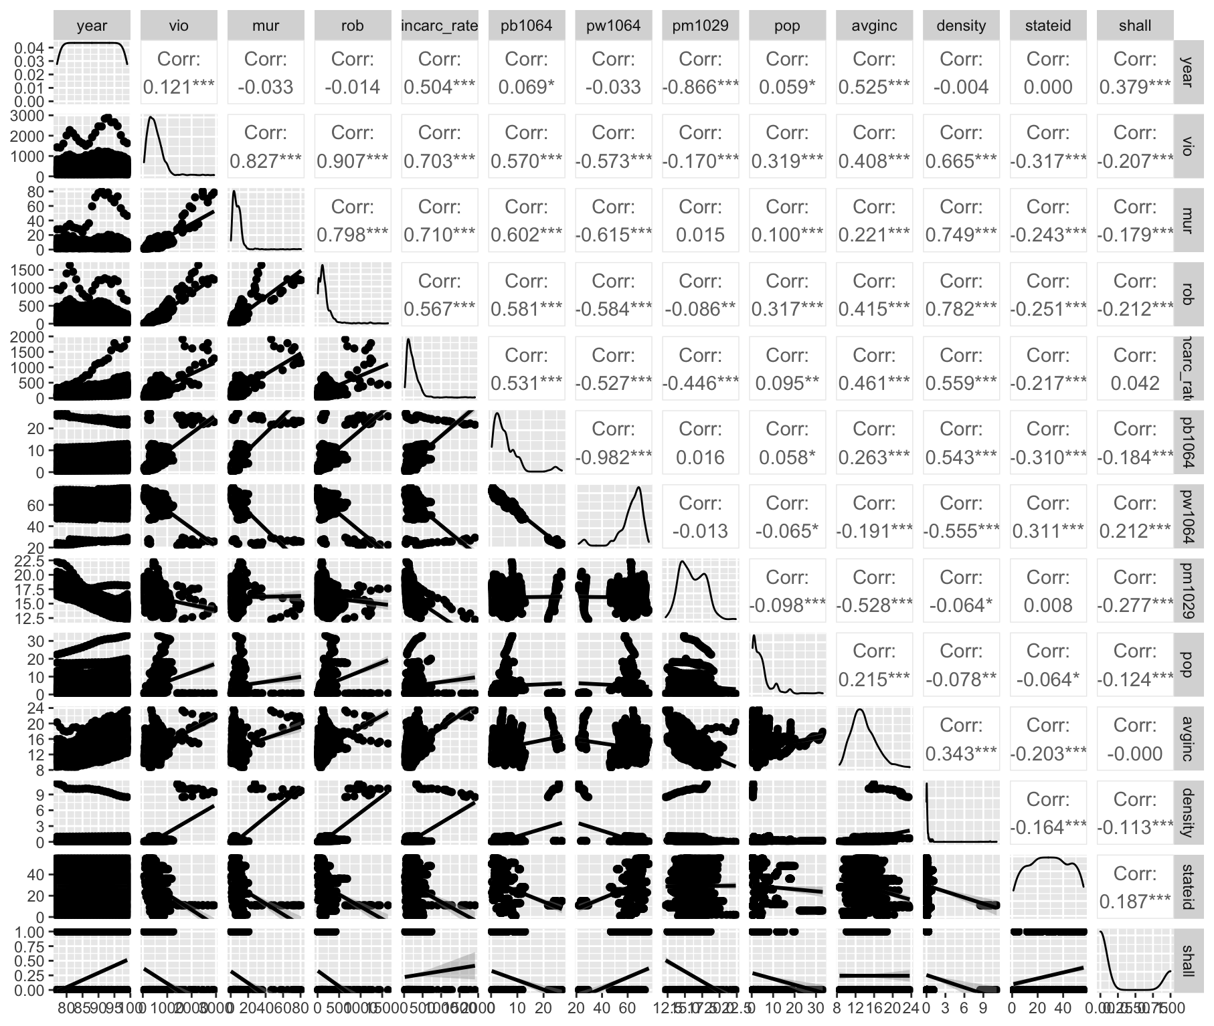

A few observations:

* Since all 3 response variables have outliers, log transformations will yield better results in regression
* Density has positive correlation with response variables, but there are outliers, so we will need to log-transform it.

We will see boxplots to get a better idea of outliers:

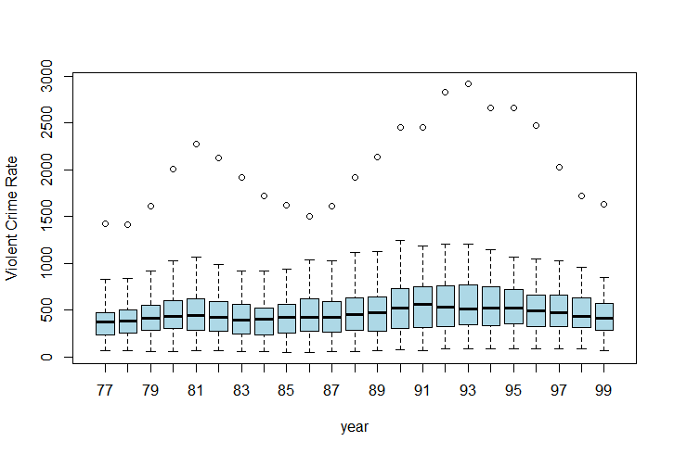

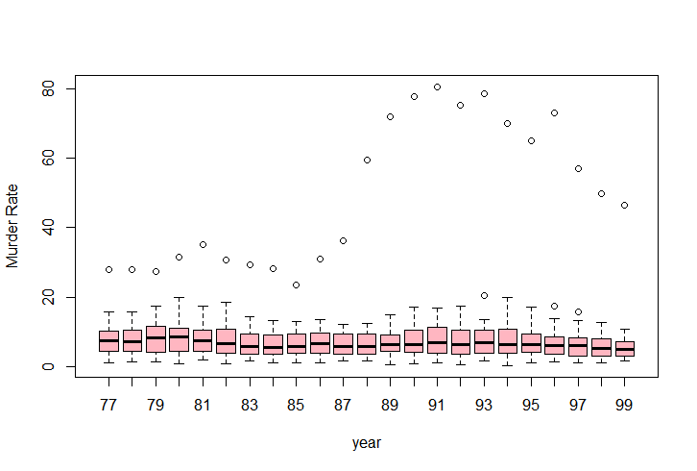

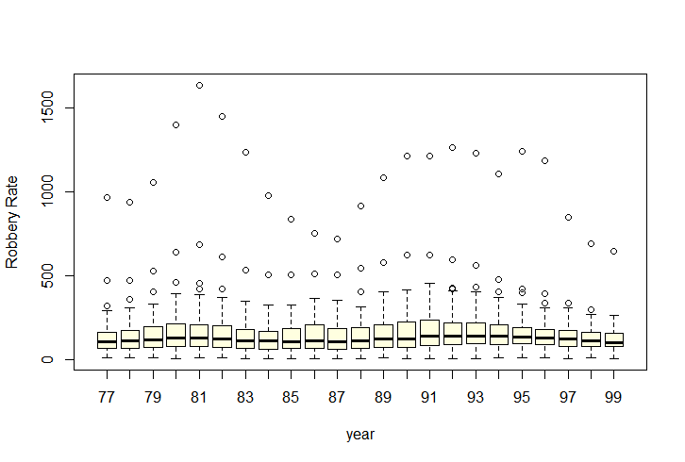

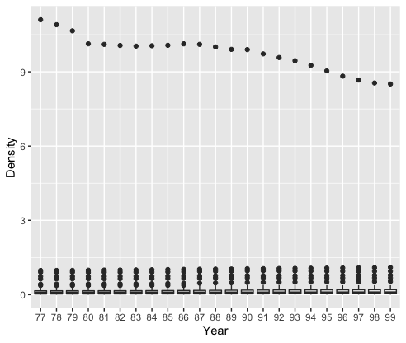

**Average Crime Over Time**

We can see that on average, its decreasing over time after increasing.

# Comparing different Types of models

To test some hypotheses regarding our economic theory, we will run different types of regression models using the sum of violence, murder, and robbery rates as the response variable. We will log transform the response variable for this testing. For this testing, we have kept all coefficients.

We are summing up the three variables for the response variable because we believe that they are all related to economic conditions. Violence, murder, and robbery are all indicators of social unrest, which can be caused by economic inequality and poverty. By summing up these three variables, we are able to get a more comprehensive measure of social unrest.

We are log transforming the response variable because it is skewed. The log transformation will help to normalize the distribution of the response variable, which will make it easier to interpret the results of the regression models.

By keeping all coefficients in the regression models, we are able to get a more complete picture of the relationship between economic conditions and social unrest. We are able to see how each coefficient contributes to the overall model, which can help us to better understand the mechanisms that are driving the relationship between these two variables.

## Pooled OLS

The first model is built using the Pooled OLS method. Pooled OLS is often a good choice for panel datasets and is used as a baseline to compare other techniques such as the fixed and random effects models.

In the above model, we can see that all variables are statistically significant except for avginc, which has a p-value of 0.284192. Since this value is not statistically significant, its interpretation might not be useful. The other coefficients (on average) can be interpreted as:

* **Year:** A increase in year results in a 3% decrease in crimes.
* **Incarc_rate:** When the incarceration rate increases by 1%, there is a 0.1% reduction in crimes.
* **Pb1064:** A 1% increase in the black population in a region between the ages of 10 and 64 results in a 5% increase in crimes.
* **Pw1064:** For every 1% increase in the population of males in an area, crimes decrease by 6%.
* **Pop:** As the population increases by 1%, crimes increase by 4%.
* **Log(density):** Crimes increase by 4% when the log of population density increases by 1%.
* **Shall:** States that have shall laws for gun control experience a 32% lower crime rate than other regions.

Based on findings from the Pooled OLS model, we can conclude that shall laws are important and have a significant impact on crimes. While the output aligns with economic theory, it is important to note that 32% is a very high number and seems unrealistic. Therefore, further analysis using other models is important before deciding.

## Entity Fixed Effects Model

* **Incarc_rate**: States with a 1 unit increase in the incarceration rate from the previous year experience on average a 0.0014% increase in crime (not statistically significant).
* **Pb1064**: States with a 1 unit increase in black people from ages 10-64 experience on average a 9.76% increase in crime.
* **Pw1064**: States with a 1 unit increase in white people from ages 10-64 experience on average a 3.99% increase in crime.
* **Pm1029**: States with a 1 unit increase in males from ages 10-29 experience on average a 4.22% decrease in crime.
* **Pop**: States with a 1 unit increase in population experience on average a 1.56% increase in crime.
* **Log**(density): States with a 1% increase in population density experience on average a 16.2% decrease in crime.
* **Avginc**: States with a 1 unit increase in average income experience on average a 1.41% decrease in crime.
* **Shall**: States that introduce a shall carry law experience on average a 3.3% decrease in crime.

Based on our findings from the Entity Fixed Effects model, we can conclude that shall carry laws do not have a statistically significant impact on crime.

## Time Fixed Effect Model

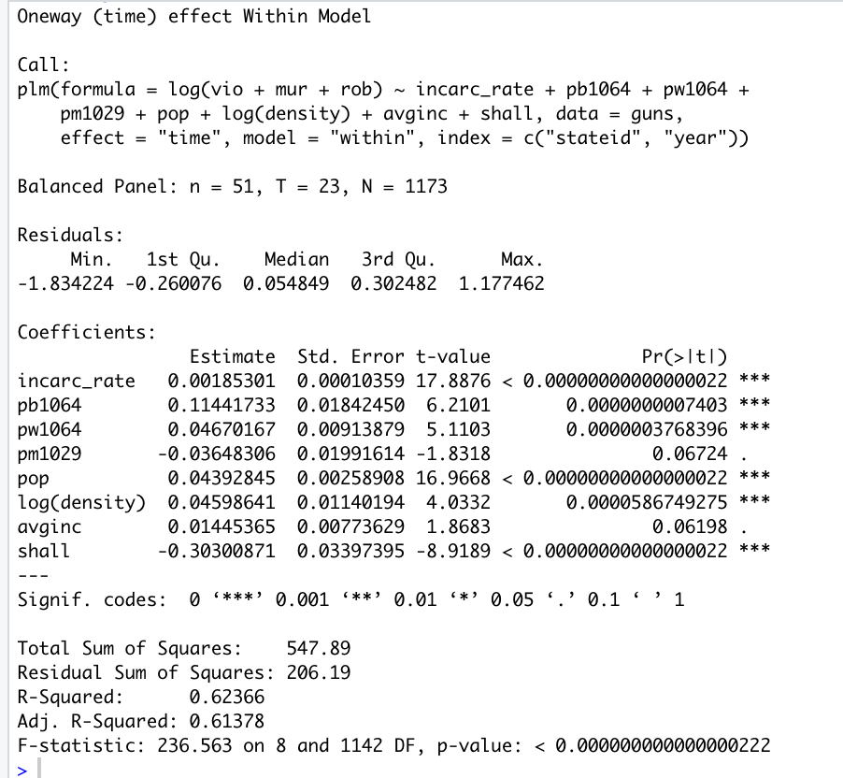

* **Incarc_rate:** The coefficient is 0.0019, which indicates that a 1 unit increase in the incarceration rate of the previous year is associated with a 0.19% increase in violent crime rates, holding other predictors constant.
* **Pb1064:** Assuming all other variables are constant, as the percent of a state’s population that is black from ages 10-64 increases by 1 unit, violent crimes increase on average by 11.44%.
* **Pw1064:** Assuming all other variables are constant, as the percent of a state’s population that is white from ages 10-64 increases by 1 unit, violent crimes increase on average by 4.6%.
* **Pm1029:** Assuming all other variables are constant, as the percent of a state’s population that is male from ages 10-29 increases by 1 unit, violent crimes decrease on average by 3.6%. But this isn’t significant at a 95% confidence level.
* **Pop:** Assuming all other variables are constant, as a state’s population increases by 1 unit, violent crimes increase on average by 4.4%.
* **log(density):** Assuming all other variables are constant, as a state’s population density increases by 1%, violent crimes increase on average by 4.5%.
* **Avg_income:** Assuming all other variables are constant, as a state’s average income increases by 1 unit, violent crimes increase on average by 1.4%.
* **Shall:** Assuming all other variables are constant, when a state has a “shall carry” law, violent crimes decrease on average by 30.3%.

Based on our findings from the Time Fixed Effects model, we can conclude that shall carry laws have a statistically significant impact on crime, and reduces crime by an average of 30%

## Time and Entity Fixed Effects Models

Here, we’ve run a regression using a Time and Entity Fixed Effects model. We have added the time as dummy variables with year 77 as reference.

The coefficients on "incarc_rate," "pb1064," "pw1064," "pop," "log(density)," "avginc," and "shall" are not statistically significant, meaning that there is not enough evidence to conclude that they have a significant effect on the dependent variable. The coefficient on "pm1029" is statistically significant at the 1% level, indicating that a 1% increase in the percentage of the population in the age range of 10-29 years old who are male is associated with a 0.07% increase in violent crime. The coefficients on the year fixed effects are also statistically significant, indicating that there is a significant time trend in the data. We can see that crime rate continues to increase, until 95, when it starts declining. We could also see this from our time charts where we mapped average crime across years

# Hypothesis Testing

To test some hypothesis regarding our economic theory, we will use the coefficients from different regression models.

***Hypothesis 1: Regions where the average annual income is lower are likely to have a higher crime rate***

*Let coefficient of average income is B1*

H0: B1<0

Ha: B1 >= 0

**From Pooled OLS:**

B1= 0.008051

Std error = 0.007515

t= 0.008051/0.007515 = 1.071

Tc = (0.95,1163) = 1.6462

t < tc so we cannot reject the null hypothesis

**From Entity FE:**

B1= -0.014131926

Std error = 0.005907880

t= -0.014131926/0.005907880 = -2.392046893302

Tc = (0.95,1114) = 1.6462

t < tc so we cannot reject the null hypothesis

**From Time FE:**

B1= 0.01445365

Std error = 0.00773629

T = 0.01445365/0.00773629= 1.8683

Tc = (0.95,1142) = 1.6462

t > tc so we reject the null hypothesis

**From Two-way FE:**

B1= 0.000522459

Std error = 0.006345933

T = 0.000522459/0.006345933 = 0.0823

Tc = (0.95,1092) =1.6463

t < tc so we cannot reject the null hypothesis.

Therefore, we can conclude that average annual income has a negative effect on crime rate. But when we take control of individual heterogeneity due to time, we can’t claim that there is a negative relationship between crime rate and income.

***Hypothesis 2: Regions with a higher percentage of men between the ages of 10 and 29 years have a higher crime rate.***

*Let the coefficient of percentage of men be B1*

H0: B1 > 0

H1: B1 <= 0

**From Pooled OLS:**

B1 = – 0.066708

Std error = 0.018869

T = – 0.066708/0.018869 = -3.535322

Tc = (0.05, 1163) = -1.6462

Since T < Tc, we reject H0 and conclude that we do not have enough statistical evidence to conclude that there is not a positive correlation between the crime rate and the percentage of males between the ages of 10 and 29 years at a 5% confidence level.

**From Entity FE:**

B1 = -0.042247066

Std error = 0.006736010

T = -0.042247066/0.006736010 = -6.271823527578

Tc = (0.05, 1114) = -1.6462

Since T < Tc, we reject H0 and conclude that we do not have enough statistical evidence to conclude that there is not a positive correlation between the crime rate and the percentage of males between the ages of 10 and 29 years at a 5% confidence level.

**From Time FE:**

B1 = -0.03648306

Std error = 0.01991614

T = -0.03648306/0.01991614 = -1.831833879457

Tc = (0.05, 1142) = -1.6462

Since T < Tc, we reject H0 and conclude that we do not have enough statistical evidence to conclude that there is not a positive correlation between the crime rate and the percentage of males between the ages of 10 and 29 years at a 5% confidence level.

**From Two-way FE:**

B1 = 0.070622137

Std error = 0.015527236

T = 0.070622137 / 0.015527236 = 4.54827485072

Tc = (0.05, 1092) = -1.6463

Since T > Tc, we cannot reject H0.

From our analysis, we can see that we don’t have the statistical support to claim that higher percentage of men can cause more crime, but when we take into account heterogeneity due to time and state, we can claim that there is a positive relationship between men and crime rate.

***Hypothesis 3: Introducing Shall-Carry Laws affects the violent crime rate***

From our analysis, we have seen that the following states initially did not have shall carry law, but introduced it later:

2, 4, 5, 12, 13, 16, 21, 22, 23, 28, 30, 32, 37, 38, 40, 41, 42, 45, 46, 47, 48, 49, 51, 54, 56

In this graph, we’ve plotted the violence rate for each state, and coloured for “shall” law status.

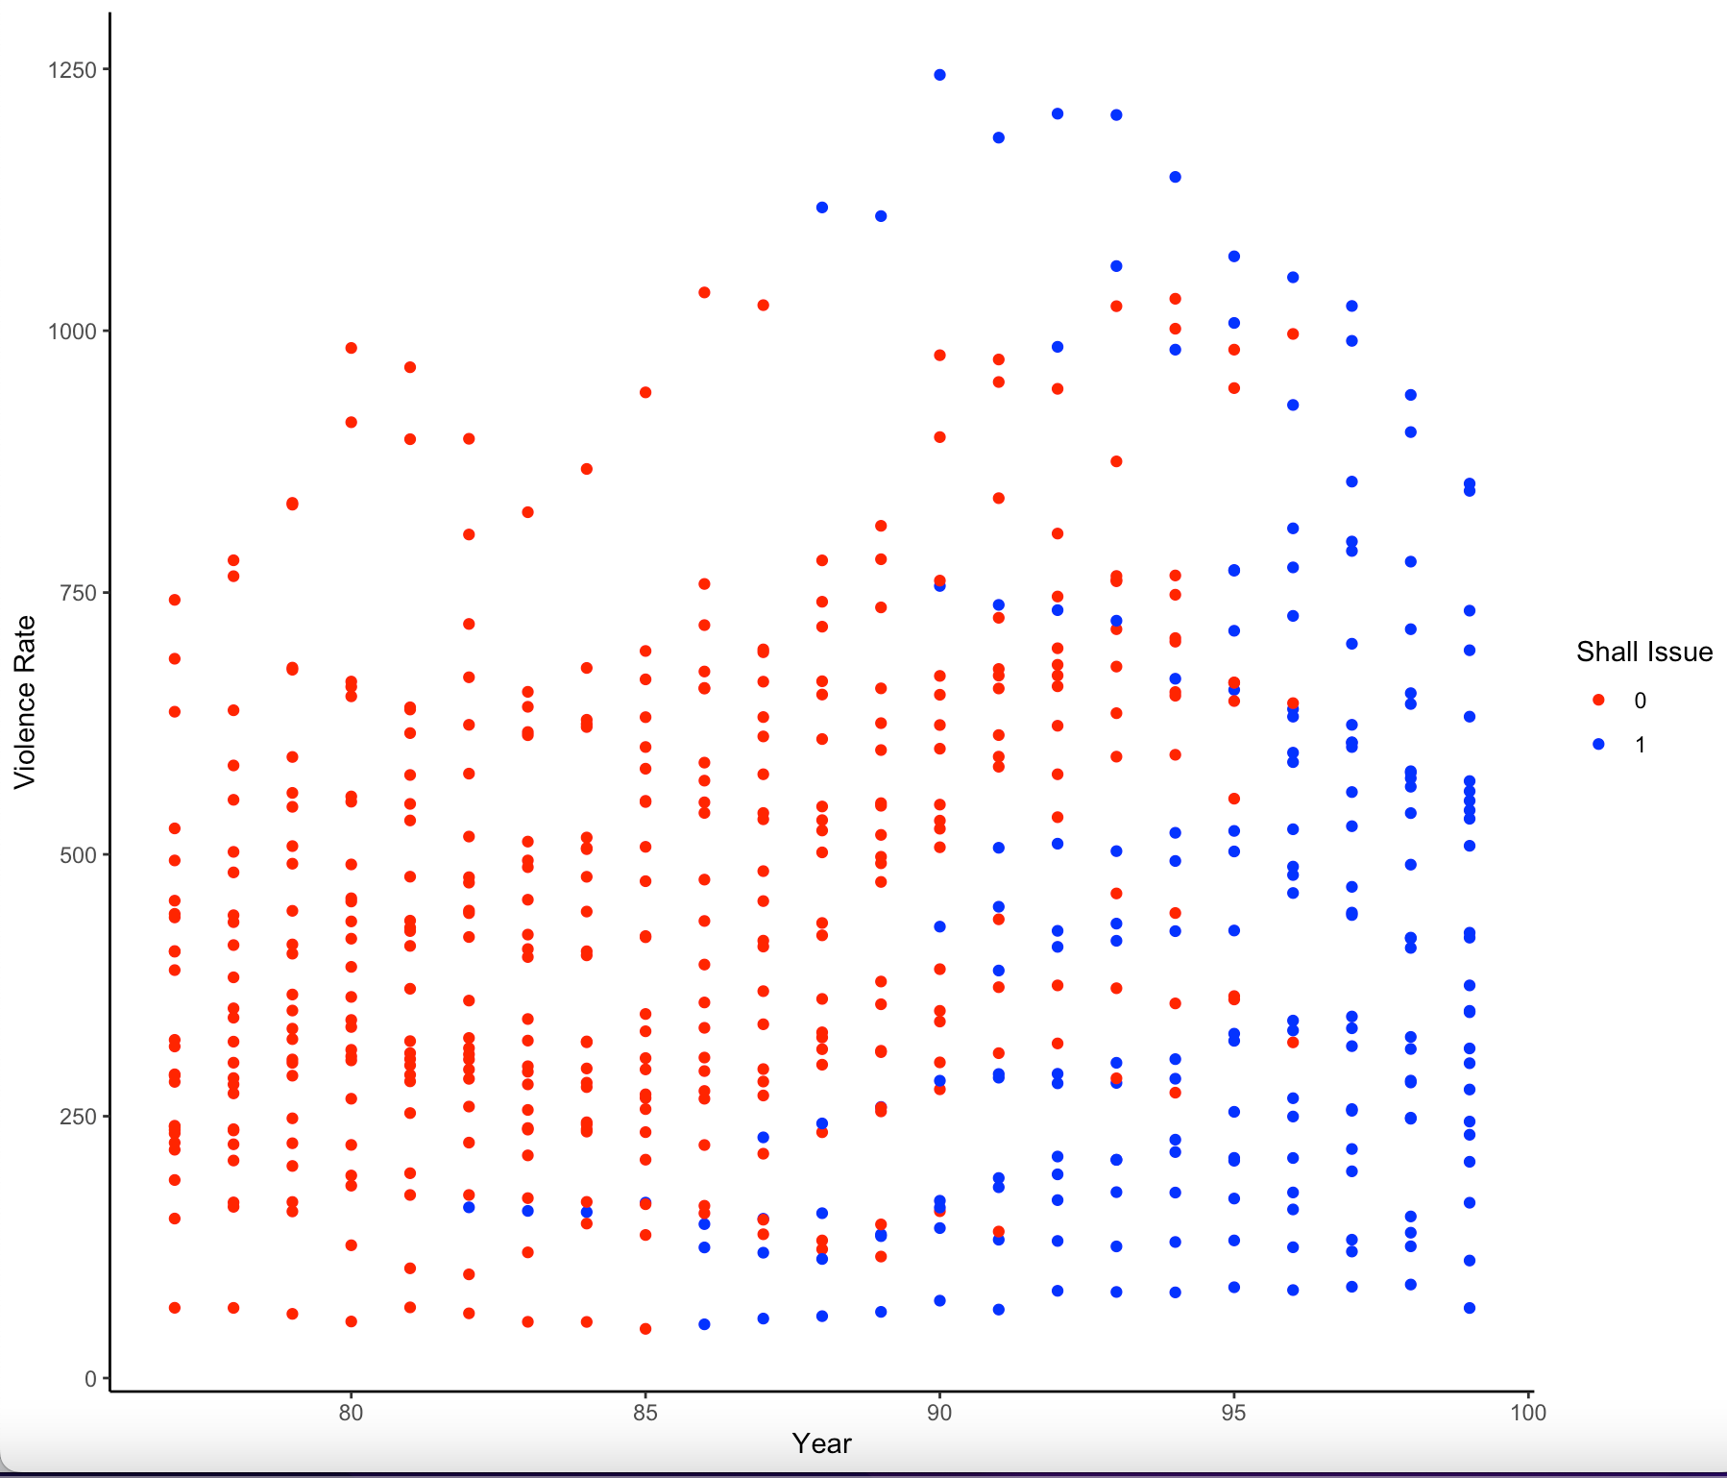

From this graph, we can tell most of these converted to shall law by 95, and there is an overall decreasing pattern in the violence rate.

We decided to get the average violence rate for those 25 states, and we can see that there is a reduction after adopting “shall-issue” law.

While these graphs are indicating that shall law reduces crime rate, a hypothesis test is also conducted.

First, we found the mean ‘vio’ for states before and after shall-carry law was introduced

Our hypothesis:

H0: There is no difference in ‘vio’ before & after introducing shall-carry law

Ha: There is a difference

We will do a paired T-Test to find out the result:

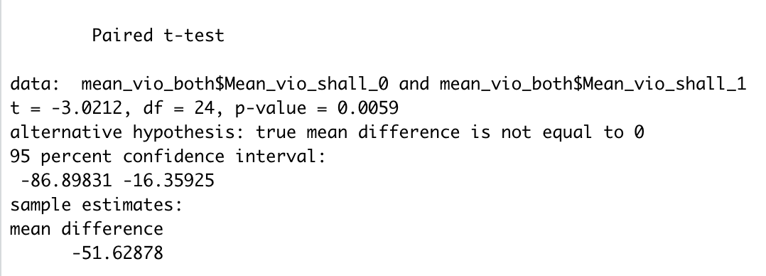

With p-value of 0.0059, so we can see that introducing shall-carry law has an effect on violence rates. And there is a mean difference of -51.62, meaning that after introducing shall-carry law, there was a mean decrease of ‘vio’ by -51.62

***Hypothesis 4: Putting criminals in jail reduces crime, i.e., a higher incarceration rate results in a lower crime rate.***

Let the coefficient of incarceration rate be B1

H0: B1 < 0

H1: B1 >= 0

**From Pooled OLS:**

B1 = 0.001814

Std error = 0.000103

T = 0.001814 / 0.000103 =17.62

Tc = (0.95, 1163) = 1.6462

Since T > Tc, we reject H0 and say that we do not have enough statistical evidence to conclude that a higher incarceration rate results in a lower crime rate at a 5% confidence level.

**From Entity FE:**

B1 = 0.000013534

Std error = 0.000070290

T = 0.1925

Tc = (0.95, 1114) = 1.6462

Since T < Tc, we cannot reject H0.

**From Time FE:**

B1 = 0.00185301

Std error = 0.00010359

T = 17.8876

Tc = (0.95,1142) = 1.6462

Since T > Tc, we reject H0 and say that we do not have enough statistical evidence to conclude that a higher incarceration rate results in a lower crime rate at a 5% confidence level.

**From Two-way FE:**

B1 = 0.000098260

Std error = 0.000068493

T = 1.4346

Tc = (0.95, 1092) = 1.6463

Since T < Tc, we cannot reject H0.

Overall, the results of the analysis are mixed. The pooled OLS model suggests that there is a statistically significant relationship between incarceration rate and crime rate, but the confidence interval is wide. The entity FE model and the two-way FE model suggest that there is no statistically significant relationship between incarceration rate and crime rate.

# Conclusions

After running regressions on 4 types of Regression Models, the results are summarized below:

* Pooled OLS: This model includes all of the data, without controlling for any time-invariant factors. The results of this model suggest that shall carry laws have a significant effect in reducing crime.
* Entity FE: This model controls for unobserved heterogeneity between entities, such as the quality of law enforcement in a given area. The results of this model suggest that shall carry laws do not have a significant effect in reducing crime.
* Time FE: This model controls for time-invariant factors, such as the overall crime rate in a given year. The results of this model suggest that shall carry laws have a significant effect in reducing crime.
* Entity and Time FE: This model controls for both unobserved heterogeneity between entities and time-invariant factors. The results of this model suggest that shall carry laws are insignificant in reducing crime.

Overall, the results are mixed, and while we have seen from T-test and Event study graph, that there is a reduction in crime after gun law adoption, from our models, we cannot claim that we have statistical evidence for this.

Based on the Entity and Time FE, which controls for heterogeneity and time invariant factors, we see that there is no evidence for this claim.

While it's significant for time FE model, it's insignificant for entity FE. In other words, the effect of shall carry laws on crime rates is consistent across time, but it varies between entities. This suggests that shall carry laws may have a different effect on crime rates in different states.

Overall, from the results of our study, we can say that we don’t have enough statistical proof to inconclusively say that gun laws can cause a reduction in crime.